**PART A**

(Part A: TO BE REFFERED BY STUDENTS)

**Experiment No. 06**

**A.1 AIM:**

Apply styling to a web page using External CSS

**A.2 Pre requisite:**

Knowledge of HTML, JavaScript and CSS

**A.3 Outcome:**

After successful completion of this experiment students will be able to:

1. Create formatted web pages/websites with attractive look and feel
2. Use external style sheets of CSS

**A.4 Theory:**

**Three Ways to Insert CSS**

There are three ways of inserting a style sheet:

* Internal style sheet
* Inline style
* External style sheet

**Internal Style Sheet**

An internal style sheet should be used when a single document has a unique style. You define internal styles in the head section of an HTML page, inside the <style> tag, like this:

<head>  
<style>  
hr {color: sienna;}  
p {margin-left: 20px;}  
body {background-image: url("images/background.gif");}   
</style>  
</head>

**Inline Styles**

An inline style loses many of the advantages of a style sheet (by mixing content with presentation). Use this method sparingly!

To use inline styles, add the style attribute to the relevant tag. The style attribute can contain any CSS property. The example shows how to change the color and the left margin of a paragraph:

<p style="color:sienna;margin-left:20px;">This is a paragraph.</p>

**External Style Sheet**

An external style sheet is ideal when the style is applied to many pages. With an external style sheet, you can change the look of an entire Web site by changing just one file.

Each page must include a link to the style sheet with the <link> tag. The <link> tag goes inside the head section:

<head>  
<link rel="stylesheet" type="text/css" href="mystyle.css">  
</head>

An external style sheet can be written in any text editor. The file should not contain any html tags. The style sheet file must be saved with a .css extension. An example of a style sheet file is shown below:

**"myStyle.css"**:

hr {color: sienna;}  
p {margin-left: 20px;}  
body {background-image: url("images/background.gif");}

When using CSS it is preferable to keep the CSS separate from your HTML. Placing CSS in a separate file allows the web designer to completely differentiate between content (HTML) and design (CSS). External CSS is a file that contains only CSS code and is saved with a ".css" file extension.

**Why use external css?**

* It keeps your website design and content separate.
* It's much easier to reuse your CSS code if you have it in a separate file. Instead of typing the same CSS code on every web page you have, simply have many pages refer to a single CSS file with the "link" tag.
* You can make drastic changes to your web pages with just a few changes in a single CSS file.

**A.5 Procedure/Task:**

1. Format the web pages designed by you and previous experiment using CSS style sheets (use both internal and inline style sheets)

2. Use all properties of CSS discussed in *class (list properties, font properties, color and background properties, text properties etc.)*

3. Prepare the document. Save and close the file and name it as **EXP05_Roll no_Batch no.**

**PART B**

(PART B: TO BE COMPLETED BY STUDENTS)

(Students must submit the soft copy as per following segments within two hours of the practical. The soft copy must be uploaded on the Blackboard or emailed to the concerned lab in charge faculties at the end of the practical in case the there is no Black board access available)

|  |  |
| --- | --- |
| Roll No.: N049 | Name: Tarun Tanmay |
| Class: MBATech CE | Batch: B3 |
| Date of Experiment: 12/9/2020 | Date/Time of Submission: |
| Grade: |  |

**B.1 Code:**

**Ext. CSS-**

header

{

background-color: gray;

height: 80px;

width: 100%

}

h1

{

font-size: 30px;

color: white;

text-align: center;

padding-top: 15px;

}

h2

{

font-size: 27px;

text-align: center;

padding-top: 50px;

}

p

{

color:black

}

body {

font-family: arial;

}

**1.**

<!DOCTYPE html>

<html>

<link rel='stylesheet' href='External.css'>

<head>

<meta charset="UTF-8">

<style>

hr {color: gray}

p.three {

border-style: dotted;

border-width: 2px;

}

div {

padding: 20px 40px;

background-color: lightblue;

}

h2{

text-decoration: underline;

}

</style>

<title>CSS</title>

</head>

<body>

<header >

<h1 >CIAO Travel Itinerary</h1>

</header> <center>

<div class="container col-md-8 col-md-offset-3" style="overflow: auto">

<h2 >Login Page</h2>

<form action="C:\Users\Pepsi\Desktop\dv sem 5\Wp\successful.html">

<div>

<label>Name</label> <br><input type="text" name="username"><br>

</div><div>

<label>Password</label> <br><input type="password" name="password"><br>

</div>

<button type="submit" class="btn btn-primary">Submit</button>

</form>

</div>

<p>Login to Check new Offers.</p>

<p class="three">Thank You</p>

</center>

</body>

</html>

**2.**

<!DOCTYPE html>

<html>

<link rel='stylesheet' href='External.css'>

<head>

<meta charset="UTF-8">

<title>Done</title>

</head>

<body>

<body>

<header >

<h1 >CIAO</h1>

</header>

<h2>Logged In</h2>

<p >SUCCESSFUL </p>

</div>

</body>

</html>

**B.2 Output:**

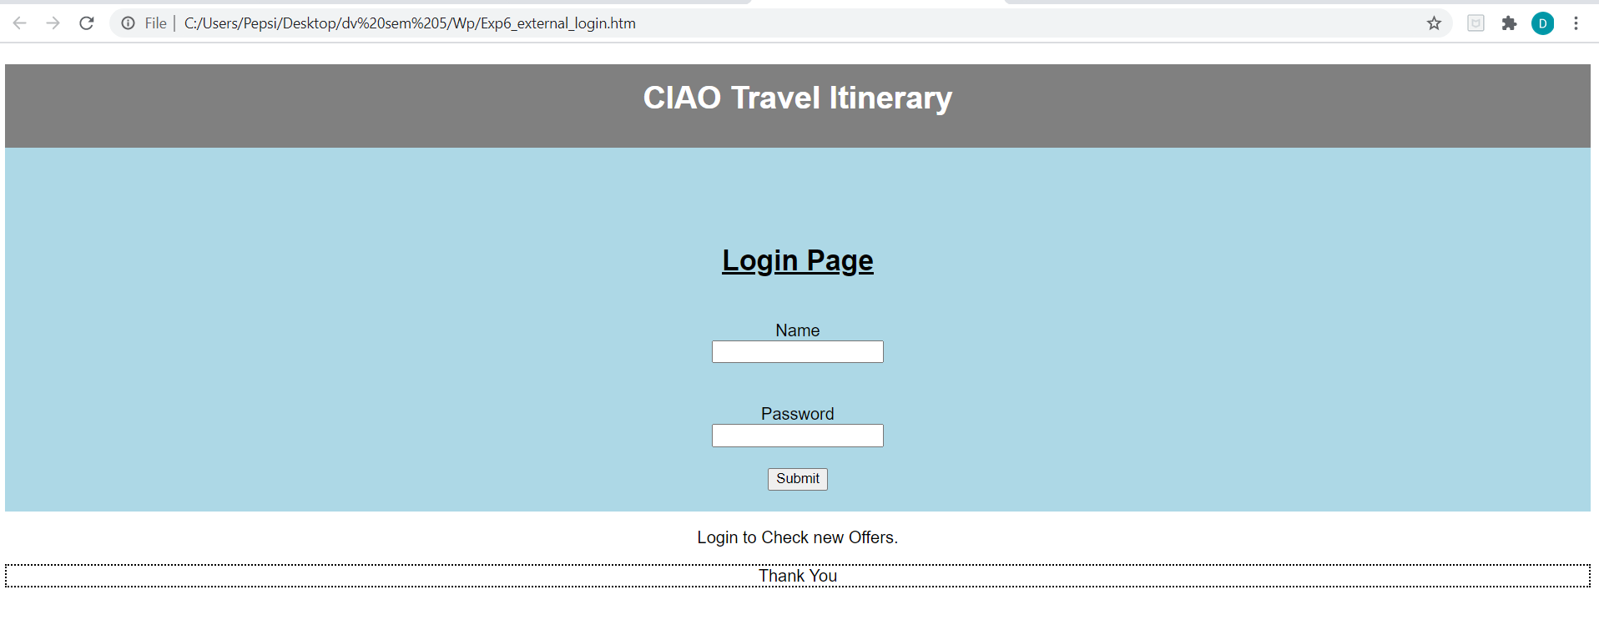

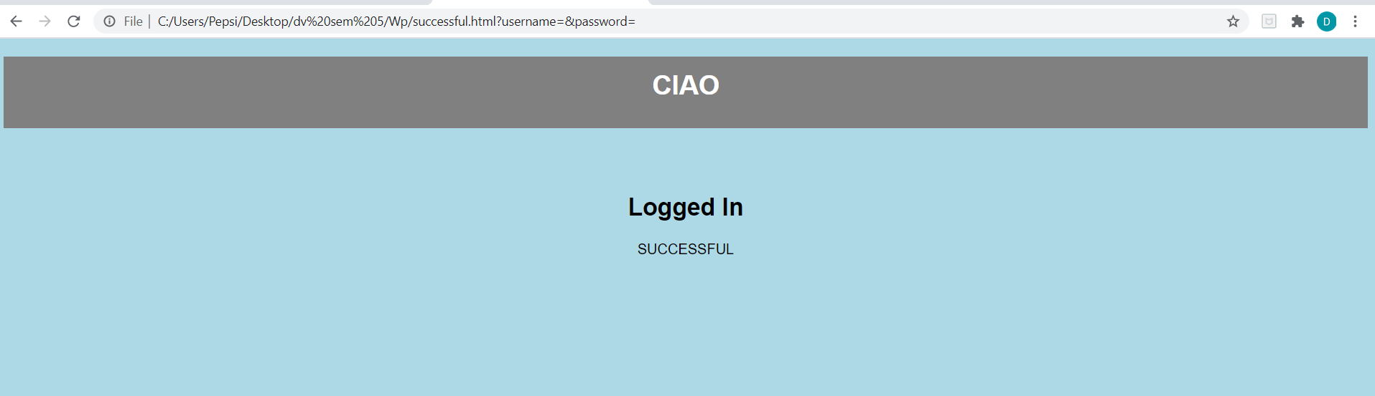

**B.3 Conclusion:**

In the above experiment, we successfully implemented External CSS. We modified a web page that was designed in earlier experiments.

**B.3 Observations and Learning:**

An external CSS page makes our code clean and enables us to apply the same layout and style on more than one web page.

**B.4 Question of Curiosity**

Q1. What are the different ways in which CSS can be linked to HTML file? Explain in detail with proper syntax.

To link CSS to an HTML file, we use the**<link>** tag that you put in the HTML’s **<head>** section. The link will look like this:

<link rel="stylesheet" type="text/css" href="stylesheet.css" media="screen"/>

In case of, internal and inline CSS no linking is required.

Q2. Explain the advantages of using External CSS for styling?

The Advantages of using External CSS are:

* One stylesheet can be linked to multiple html pages thus increasing reusability.
* Since the code isn’t written with the main HTML, the codes become clean, sorted and easy to interpret.